Tips for Using the Clearwater County Sales List

The list of sales includes only sales that are “Good Sales” as determined by County and State standards from October 1st through Sept 30th of the sales study period.

Filtering: The spreadsheet is designed for you to select or filter the type of sales you are searching for.
- At the top of each column by the heading is a filtering option. 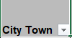
- In this example, under the “City Town” column of the spreadsheet, you may want to see only sales from a certain city or township. Click on the down arrow button circled in red above, then uncheck “select all” to uncheck all of the selected variables, then check the box next to the desired city or township (you may select multiple), and then select “OK”. Now only the sales from those selected areas will appear.
- When you select this button above any column, you will see a list of every option included in that column. By using these filters you are able to filter the sales down to a selection of information you desire in any combination.
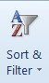
- If you decide you want to go back to the original list, on the right hand side of your
“Home” tab options, select the “sort and filter” option and then select “clear filters”.

Hiding Columns:

- If you want to eliminate columns that are unnecessary for your search, you can either delete them
(which means they can’t come back), or you can hide columns that you don’t want to see. To hide a column, select the column letter at the top to highlight the entire column. Right click on the highlighted column and select “Hide”.
- To bring a column back so you can see it again, select the columns before and after the hidden column using a swiping motion. Right click on the highlighted columns and select “Unhide”.

Rejected Sales: You may be aware of a sale or sales that have occurred during the sales study period that do not appear in the sales listing. There are several reasons that this may happen. Not all sales are deemed to be good sales to be used for our study. The list of sales is approved by the Minnesota Department of Revenue. On page three of this report you will see the list of reason why a sale can be “rejected” or deemed not good for the study.

Sales Ratio Study Property Type (PT) Codes

- Residential (less than 4 units)
- Apartment (4 or more units)
- Non-Commercial Seasonal Recreational Residential (with buildings)
- Commercial (with buildings)
- Industrial (with buildings)
- Public Utility
- Railroads
- Mineral
14 Seasonal Recreational Commercial and Resorts
- Personal Property
- Residential - Bare Land
- Apartment - Bare Land
- Seasonal Recreational - Bare Land
- Commercial - Bare Land
- Industrial - Bare Land
- Exempt
- Agricultural Class 2a - Land with Buildings (34.5 or more acres)
- Agricultural Class 2a - Bare Land (34.5 or more acres)
- Rural Vacant Land Class 2b - Land with Buildings (34.5 or more acres)
- Rural Vacant Land Class 2b - Bare Land (34.5 or more acres)
- Managed Forest Land Class 2c (34.5 or more acres)
- Agricultural Class 2a - Land with Buildings (less than 34.5 acres)
- Agricultural Class 2a - Bare Land (less than 34.5 acres)
- Rural Vacant Land Class 2b - Land with Buildings (less than 34.5 acres)
- Rural Vacant Land Class 2b - Bare Land (less than 34.5 acres)
- Managed Forest Land Class 2c (less than 34.5 acres)
- Mixed Agricultural Class 2a & Rural Vacant Land Class 2b - Land with Buildings (34.5 or more ac)
- Mixed Agricultural Class 2a & Rural Vacant Land Class 2b - Bare Land (34.5 or more acres)
- Mixed Agricultural Class 2a & Rural Vacant Land Class 2b - Land with Buildings (less than 34.5 ac)
- Mixed Agricultural Class 2a & Rural Vacant Land Class 2b - Bare Land (less than 34.5 acres)

Sale Reject Reasons
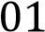
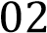
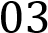
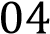
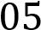
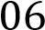 | 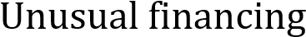
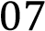 | Physical change
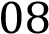
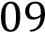
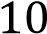
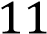 | 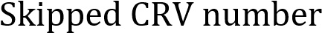
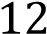 | 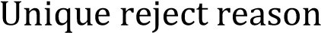
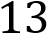
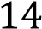
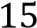
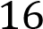
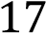
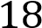
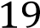
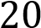
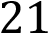
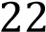
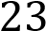
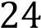
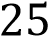
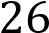
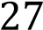
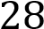
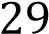 | 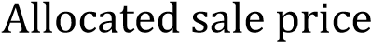
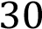
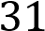 | 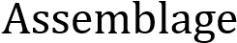

The first two digits of a parcel number represent the
City or Township it is located in.

Example:
03.009.0200 begins with 03
and is located in
Copley Township.
Clearwater County

Number | Township / City Name
01 | Bear Creek Township
02 | Clover Township
03 | Copley Township
04 | Dudley Township
05 | Eddy Township
06 | Falk Township
07 | Greenwood Township
08 | Hangaard Township
09 | Holst Township
10 | Itasca Township
11 | LaPrairie Township
12 | Leon Township
13 | Minerva Township
14 | Moose Creek Township
15 | Nora Township
16 | Pine Lake Township
17 | Popple Township
18 | Rice Township
19 | Shevlin Township
20 | Sinclair Township
21 | Long Lost Lake Township
22 | Winsor Township
23 | City of Bagley
24 | City of Clearbrook
25 | City of Gonvick
26 | City of Leonard
27 | City of Shevlin

